Computer Networks Assignment

**Module 1**

* 1. Draw and explain the functionality of each layer in the ISO-OSI Model. How is the TCP/IP Model different from the ISO-OSI Model? What is the significance of the layered architecture?
  2. What do you understand by the following terms? Explain with suitable diagrams and examples as required.
     1. Delay-Bandwidth Product
     2. Protocol
     3. Algorithm
     4. Carrier Frequency
     5. Modulation
     6. Bit Rate
     7. Baud Rate
     8. Baseline Wandering
     9. Constellation Diagram
     10. Quantization
  3. Explain, compare and contrast between the following:
     1. Analog and Digital Signals
     2. Frequency Domain and Time Domain
     3. Line Coding and Block Coding
     4. Circuit Switched Network and Packet Switched Network
     5. Attenuation and Distortion
     6. Noise and Signal
     7. Shannon’s Theorem and Nyquist’s Theorem
     8. Throughput and Latency
     9. Multistage Switch vs. Crossbar Switch
  4. Draw the signals corresponding to the data 01100101 if the following Line Coding Techniques are used:
     1. NRZ-L
     2. NRZ-I
     3. Manchester
     4. Differential Manchester
  5. Solve the following Problems:
     1. We have a channel with a 1-MHz Bandwidth. The SNR of this channel is 63. What are the appropriate bit rate and signal level.
     2. A telephone line normally has a bandwidth of 3000 Hz (300 to 3300 Hz) assigned for data communications. The signal-to-noise ratio is usually 3162. What will be the capacity of the channel?
     3. What are the propagation time and the transmission time for a 2.5-kbyte message (an e-mail) if the bandwidth of the network is 1 Gbps? Assume that the distance between the sender and the receiver is 12,000 km and that light travels at 2.4 x 108 m/s.
  6. Draw the frequency Domain Diagram of the following Signal:

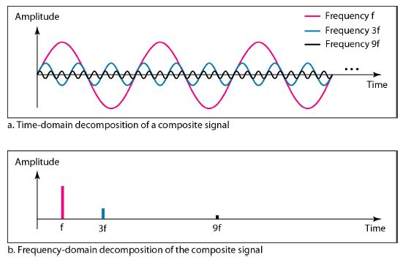

* 1. What is the bandwidth of the following signal?

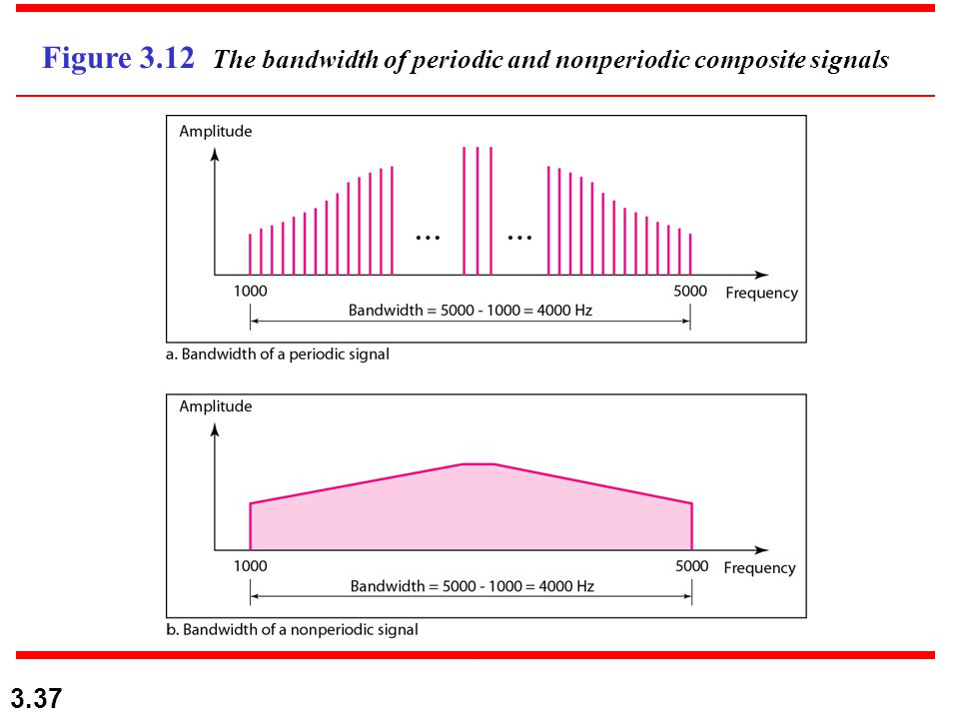

**Module 2**

* 1. Explain with suitable diagram how the following techniques can be used to detect and correct error. State if the technique has any limitation.
     1. 1D Parity
     2. 2D Parity
     3. Hamming Code
     4. Checksum
     5. CRC
  2. Compare and Contrast the following with suitable examples:
     1. Bit Stiffing vs Byte Stuffing
     2. Flow Control vs Error Control
     3. Stop and Wait vs Stop and Wait ARQ
     4. Selective Repeat ARQ vs Go-Back-N ARQ
     5. Polling vs Reservation
     6. CSMA/CA vs CSMA/CD
     7. Pure ALOHA vs. Slotted ALOHA
  3. What do you understand by the following:
     1. Piggybacking
     2. Exponential Backoff Algorithm
     3. TDMA
     4. FDMA
     5. CDMA
  4. Solve the following problems:
     1. A network using CSMA/CD has a bandwidth of 10 Mbps. If the maximum propagation time (including the delays in the devices and ignoring the time needed to send a jamming signal, as we see later) is 25.6 μs, what is the minimum size of the frame?
     2. Consider a 50-kbps satellite channel with a 500-msec round-trip propagation delay. Frame size is 1000 bit. Find the following:-
        1. If stop and wait protocol is used in the above channel, calculate for what percentage of time the sender will be idle.
        2. If sliding window protocol is used, what should be the ideal window size of the sender
     3. Assume that, in a Stop-and-Wait ARQ system, the bandwidth of the line is 1 Mbps and 1 bit takes 20 ms to make a round trip. What is the bandwidth-delay product? If the system data frames are 1000 bits in length, what is the utilization % of the link?
     4. Assume that, in a Stop-and-Wait ARQ system, the bandwidth of the line is 1 Mbps and 1 bit takes 20 ms to make a round trip. What is the bandwidth-delay product? If the system data frames are 1000 bits in length, what is the utilization % of the link?
  5. Explain with a suitable diagram what happens when a new bridge is connected to a LAN. What happens if the newly connected bridge forms a loop in the network? How can we solve it? Explain the utility of the Backward Learning Algorithm in the context of the newly connected bridge. Use suitable diagram.
  6. What is the ideal receiver window size in the selective repeat protocol? If the receiver window size is considered to be greater than **2(m-1)**will there be any problem?
  7. What should be the ideal size of the sender window in the Go-Back-N protocol? What happens when it is equal to 2m.

**Module 3**

1. Explain the following terms with suitable diagram and/or examples:
   1. Network Address translation
   2. Address Resolution Protocol
   3. Subnetting
   4. Two-Node Loop Instability Problem
   5. Three Node Loop Instability Problem
   6. Count to Infinity Problem and with possible solutions
2. Compare and Contrast the following with suitable diagrams and examples:
   1. non-adaptive and adaptive routing protocols
   2. Link State vs Distance Vector Routing Protocols
   3. Static routing vs. Dynamic Routing.
   4. Classless vs. Classfull Addressing
   5. Net id vs. Host id
3. Explain the behaviour of the Network Throughput (Graphical) as the congestion in a network increases. State the cause of the behaviour.
4. Solve the following problems:
   1. Router J has 4 neighbours A, I, H, K. The following list summarizes the various delay. Using the distance vector routing protocol determine the routing table entry for J to the router G.

|  |  |  |  |
| --- | --- | --- | --- |
| JA: 8 | JI:10 | JH:12 | JK:6 |
| A to G: 18 | I to G: 31 | H to G: 6 | K to G: 31 |

* 1. Construct the link state packets for the following network.

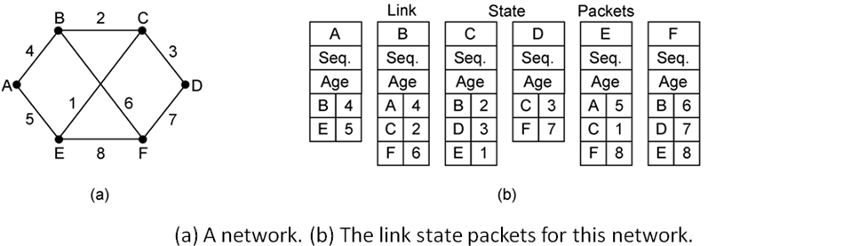

* 1. An organization is granted the block 130.34.12.64/26. The organization needs to have four subnets. What are the subnet addresses and the range of addresses for each subnet?
  2. Find the netid and the hostid of the following IP addresses :
     1. 19.34.21.5
     2. 220.34.8.9
  3. An organization is given the block 17.12.40.0/26, which contains 64 addresses. The organization has three offices and needs to divide the addresses into three sub-blocks of 32, 16, and 16 addresses. What should be the network mask of the 3 sub-blocks?
  4. A block of addresses is granted to a small organization. We know that one of the addresses is 192.26.47.39/28. What is the first address, the last address and the number of IP addresses available in the block?
  5. Identify the classes of the following classful IP addresses:
     1. 192.168.32.15
     2. 10.10.9.10
     3. 155.176.35.64
     4. 240.89.37.12

**Module 4**

1. What is meant by "connection oriented” in context of the TCP protocol?
2. Explain the SYN flooding attack with possible solutions.
3. What is more suitable for interactive real time applications, TCP or UDP, and why?
4. Explain with diagram how TCP establish as well as terminate a connection using three way handshaking.
5. Explain with suitable diagrams how congestion can be controlled using
   1. Back pressure and
   2. Choke packets.
6. Explain the significance and working of the Leaky Bucket and the Token Bucket Algorithms with suitable diagram.
7. Explain the following terms:
   1. Bandwidth
   2. Throughput
   3. Packet End-to-End Delay
   4. Jitter
   5. Silly Window Syndrome with possible solution
8. What are the various timers associated with the TCP Protocol.
9. Explain the process of congestion control in TCP.
10. Explain how the receiver in TCP controls the flow in the network.
11. Explain the working of the UDP Protocol.
12. Explain how the closed loop congestion control strategies differ from the open loop congestion control strategies.